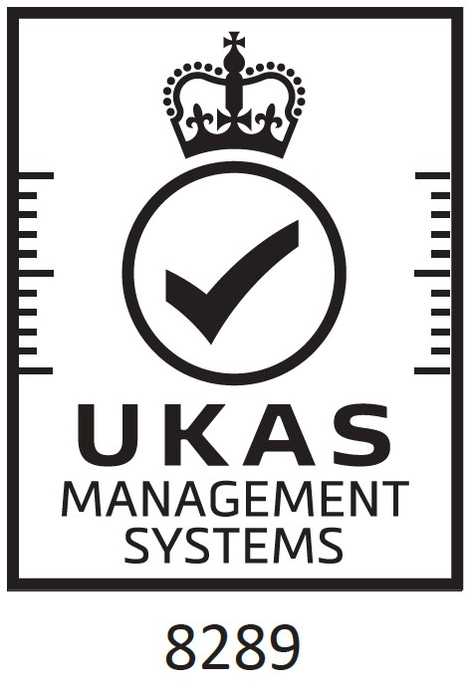

CERTIFICATE OF REGISTRATION
The management system of certificate number
222537

G2 Digital Video Ltd
Blacknest House, Blacknest Industrial Estate, Blacknest Road,
Blacknest, Alton, Hampshire, GU34 4PX, United Kingdom
has been assessed and certified as meeting the requirements of:
ISO 9001:2015
The Design, Manufacture and Assembly of Computers for a variety of Independent Software Vendors across a broad
range of industries throughout the UK and Europe.
Further clarifications regarding the scope of this certificate and the applicability of requirements may be obtained by
consulting the certifier.

Valid from:
Initial certification:
22
October
2015
Latest issue:
17
October
2025
Expiry date:
21
October
2027
Subject to annual assessments.
Authorised by
Mike Tims
Chief Executive Officer

british-assessment.co.uk
Certificate issued by Amtivo Group Limited T/A British Assessment Bureau Ltd.
Certification is conditional on maintaining the required performance standards throughout the certified period of registration.
Amtivo Group Limited. 30 Tower View, Kings Hill, Kent, ME19 4UY.

